**Day 4**

**Java Array and Java OOP Part 1**

**Java Array**

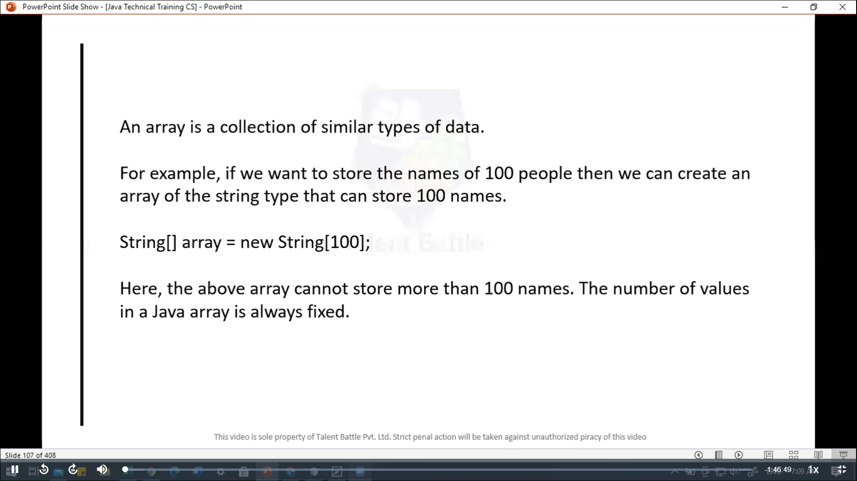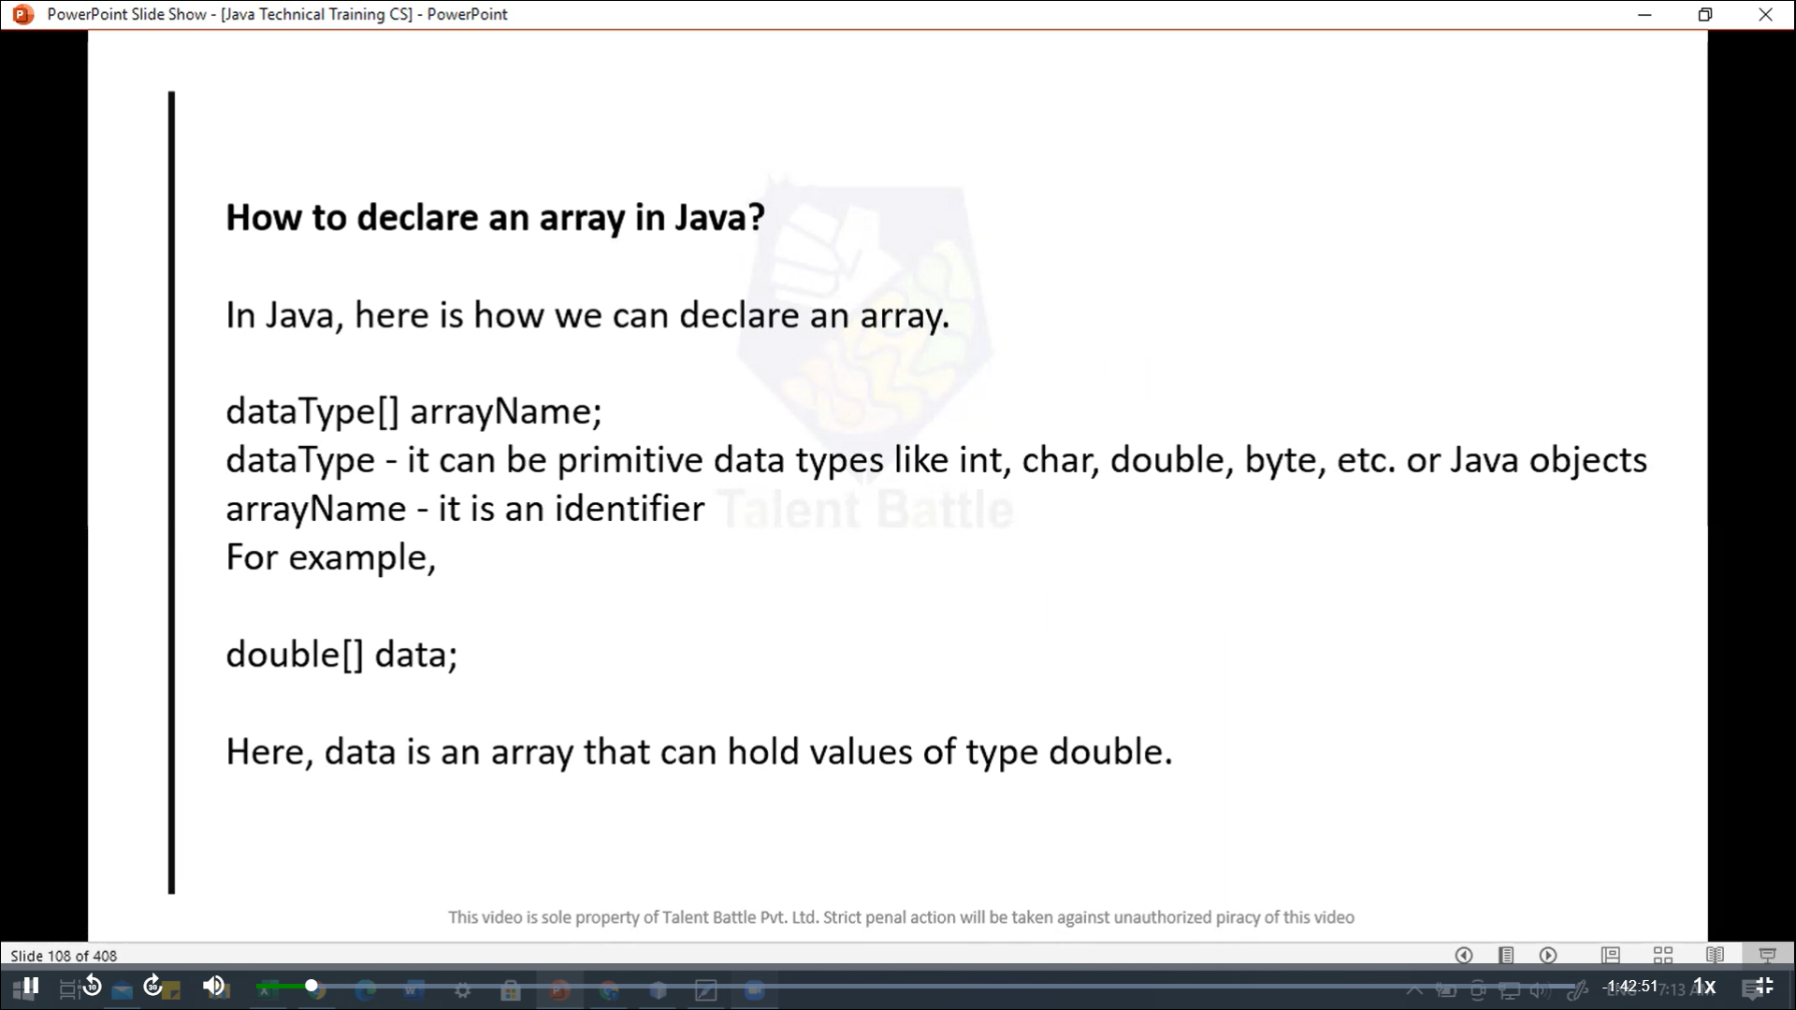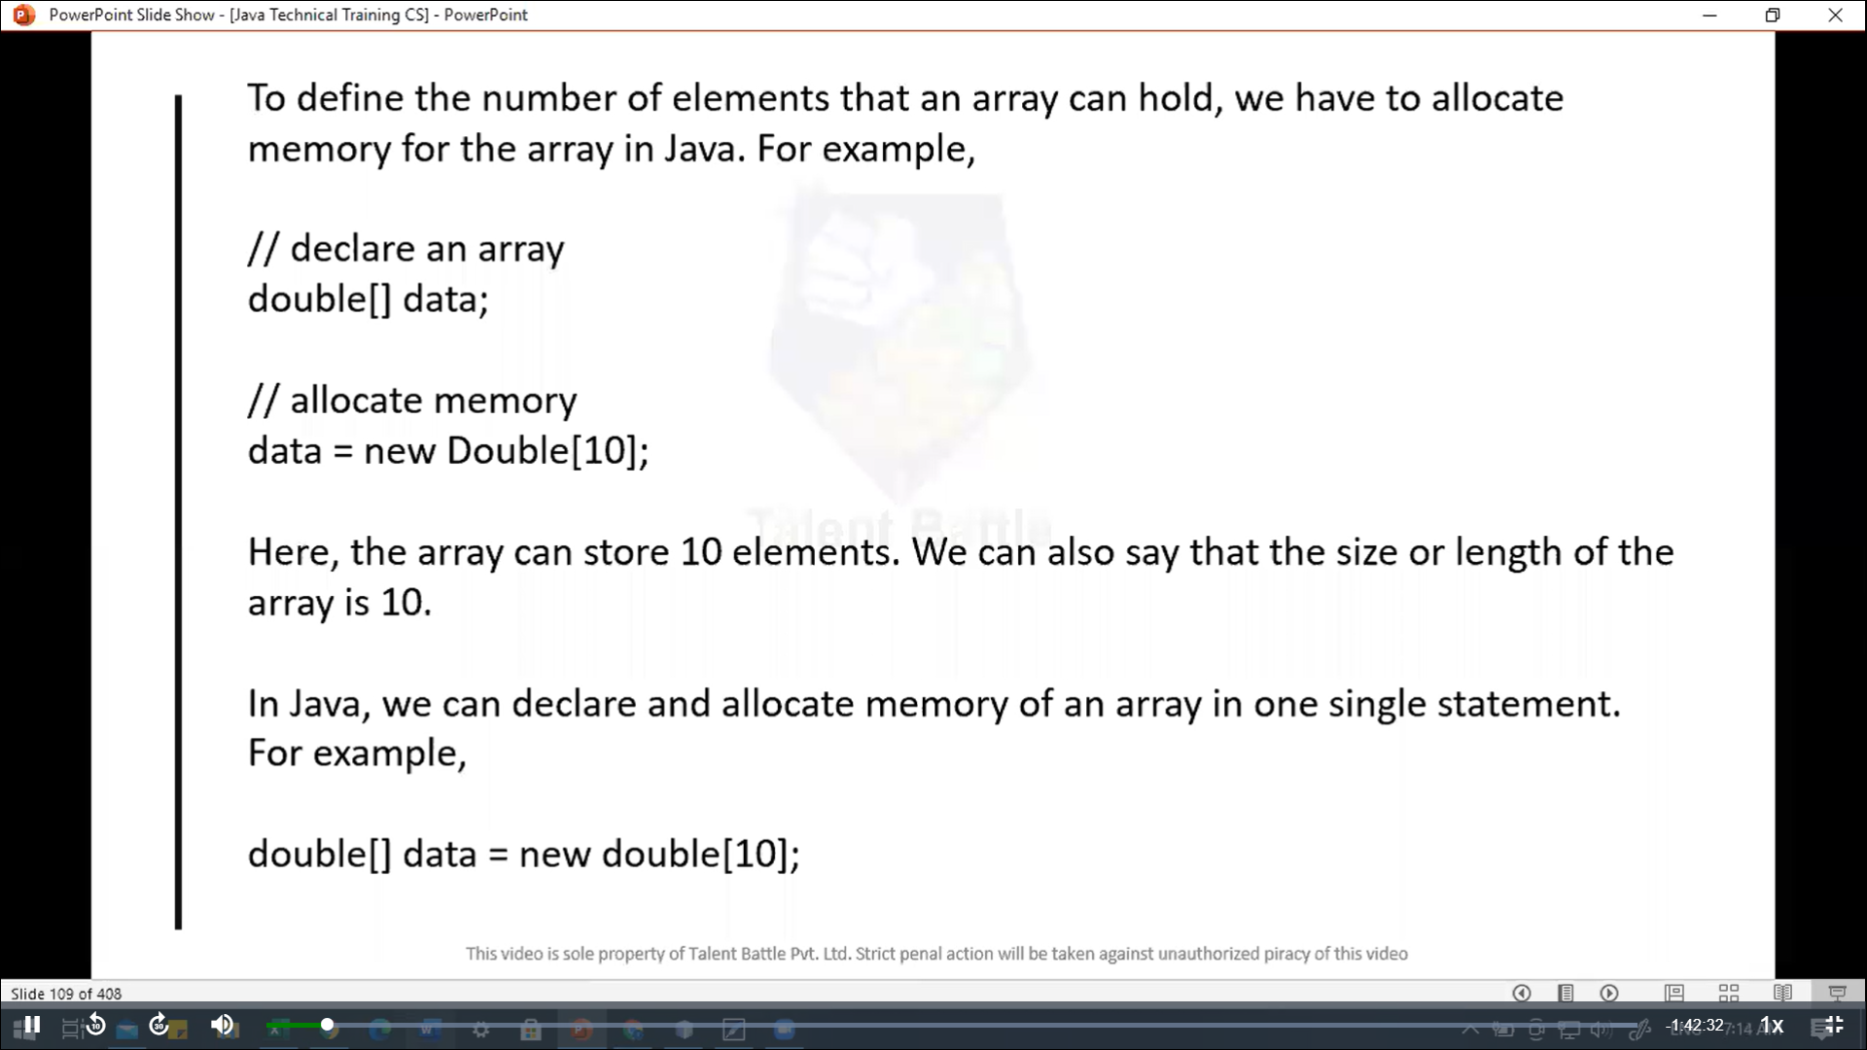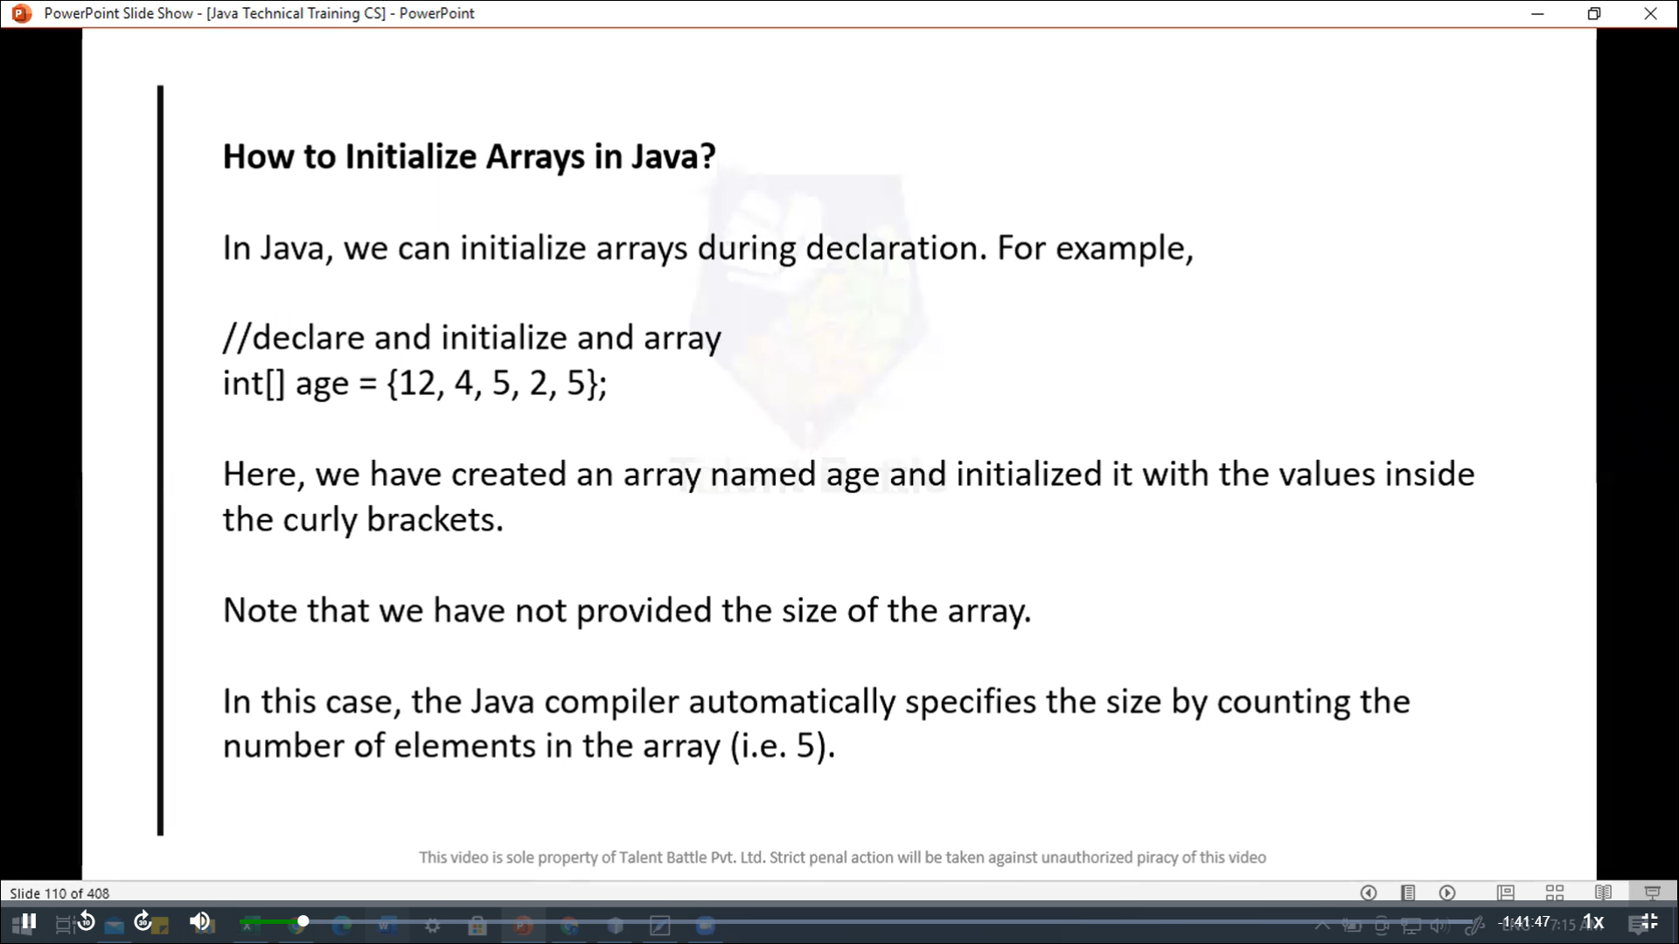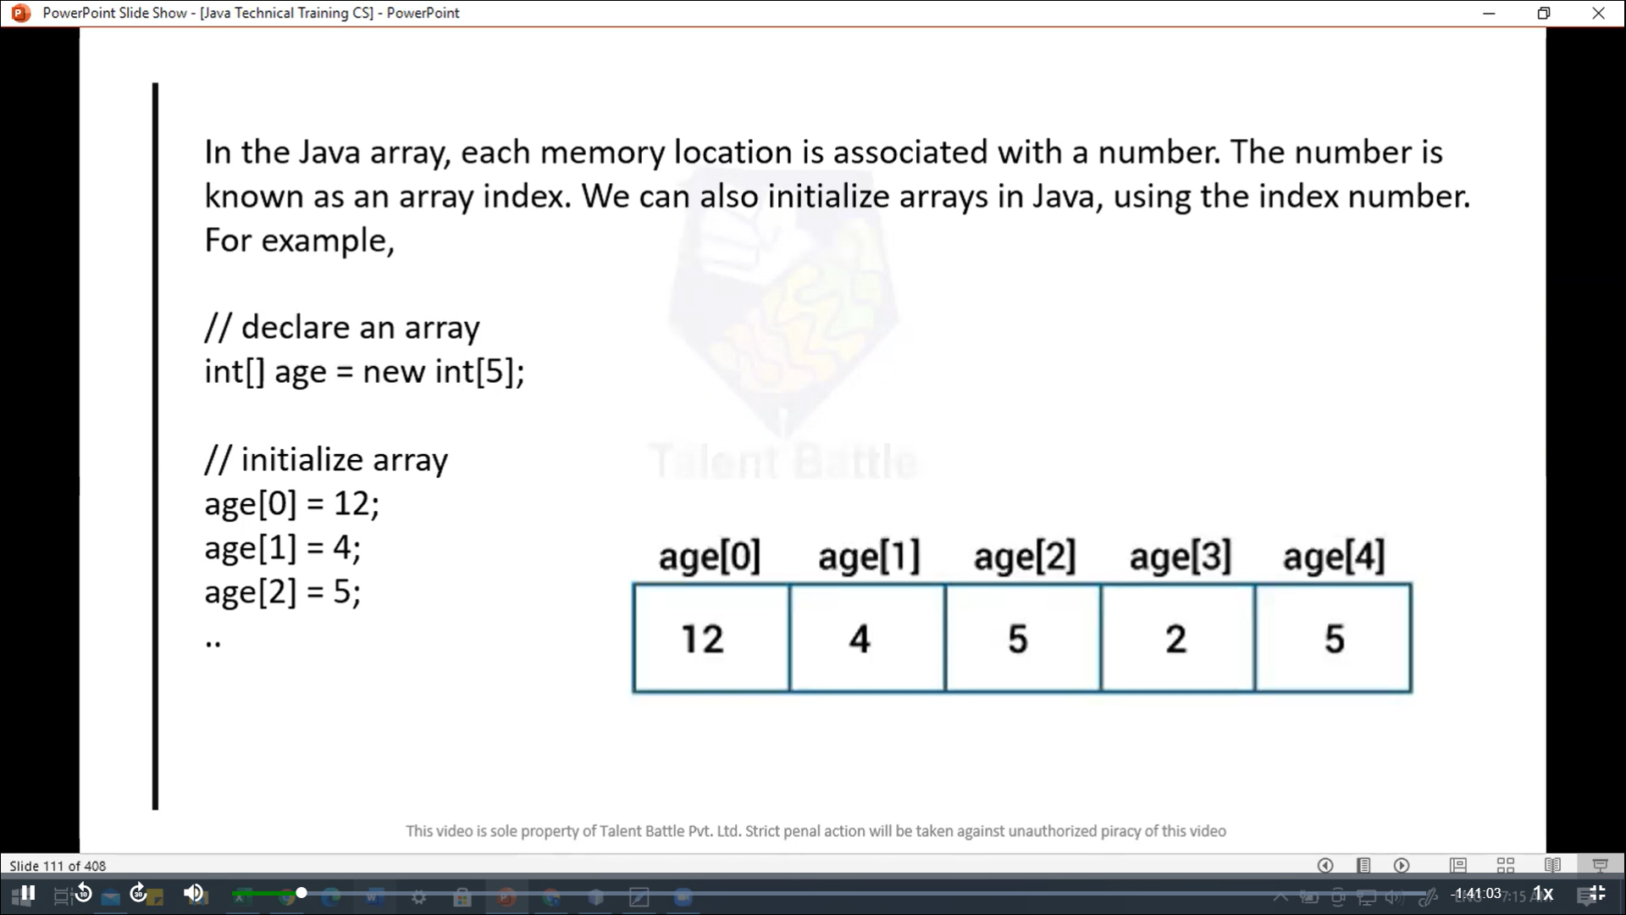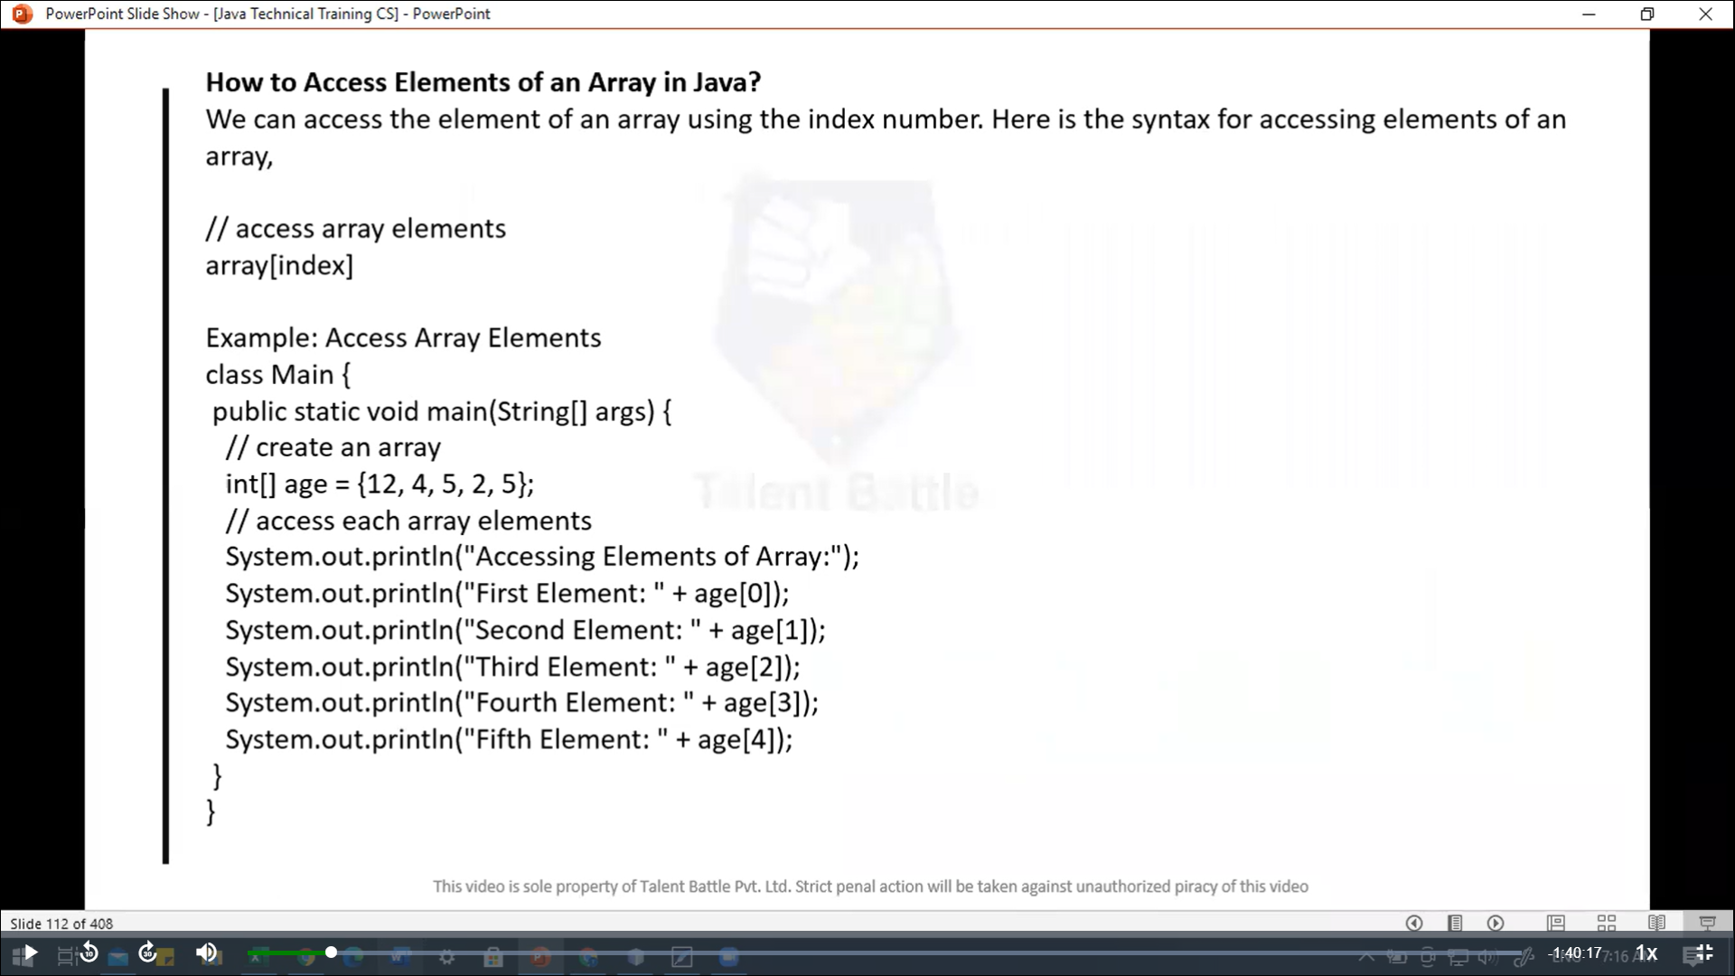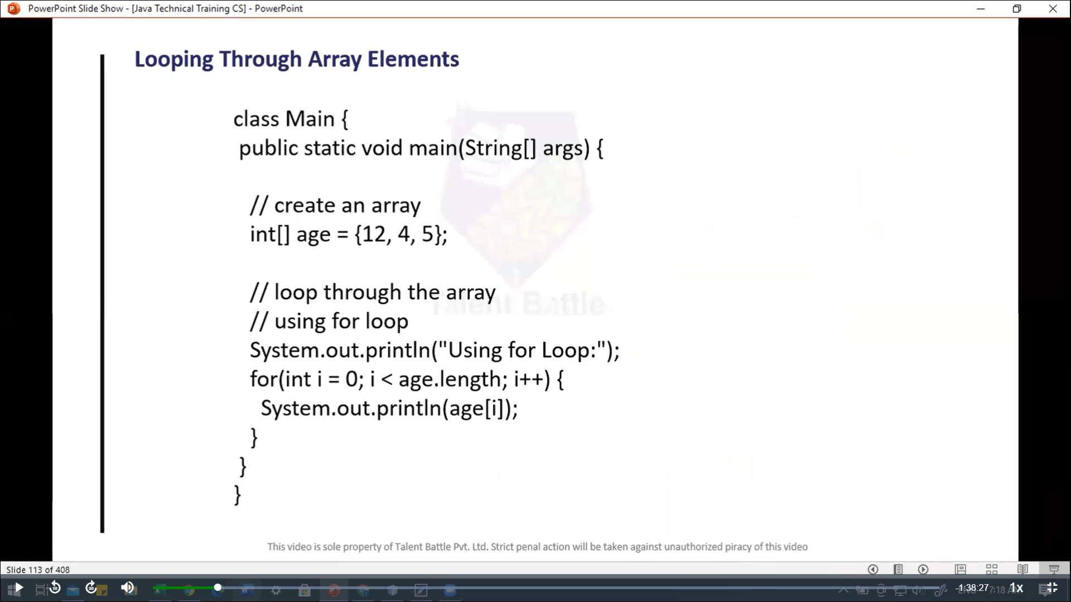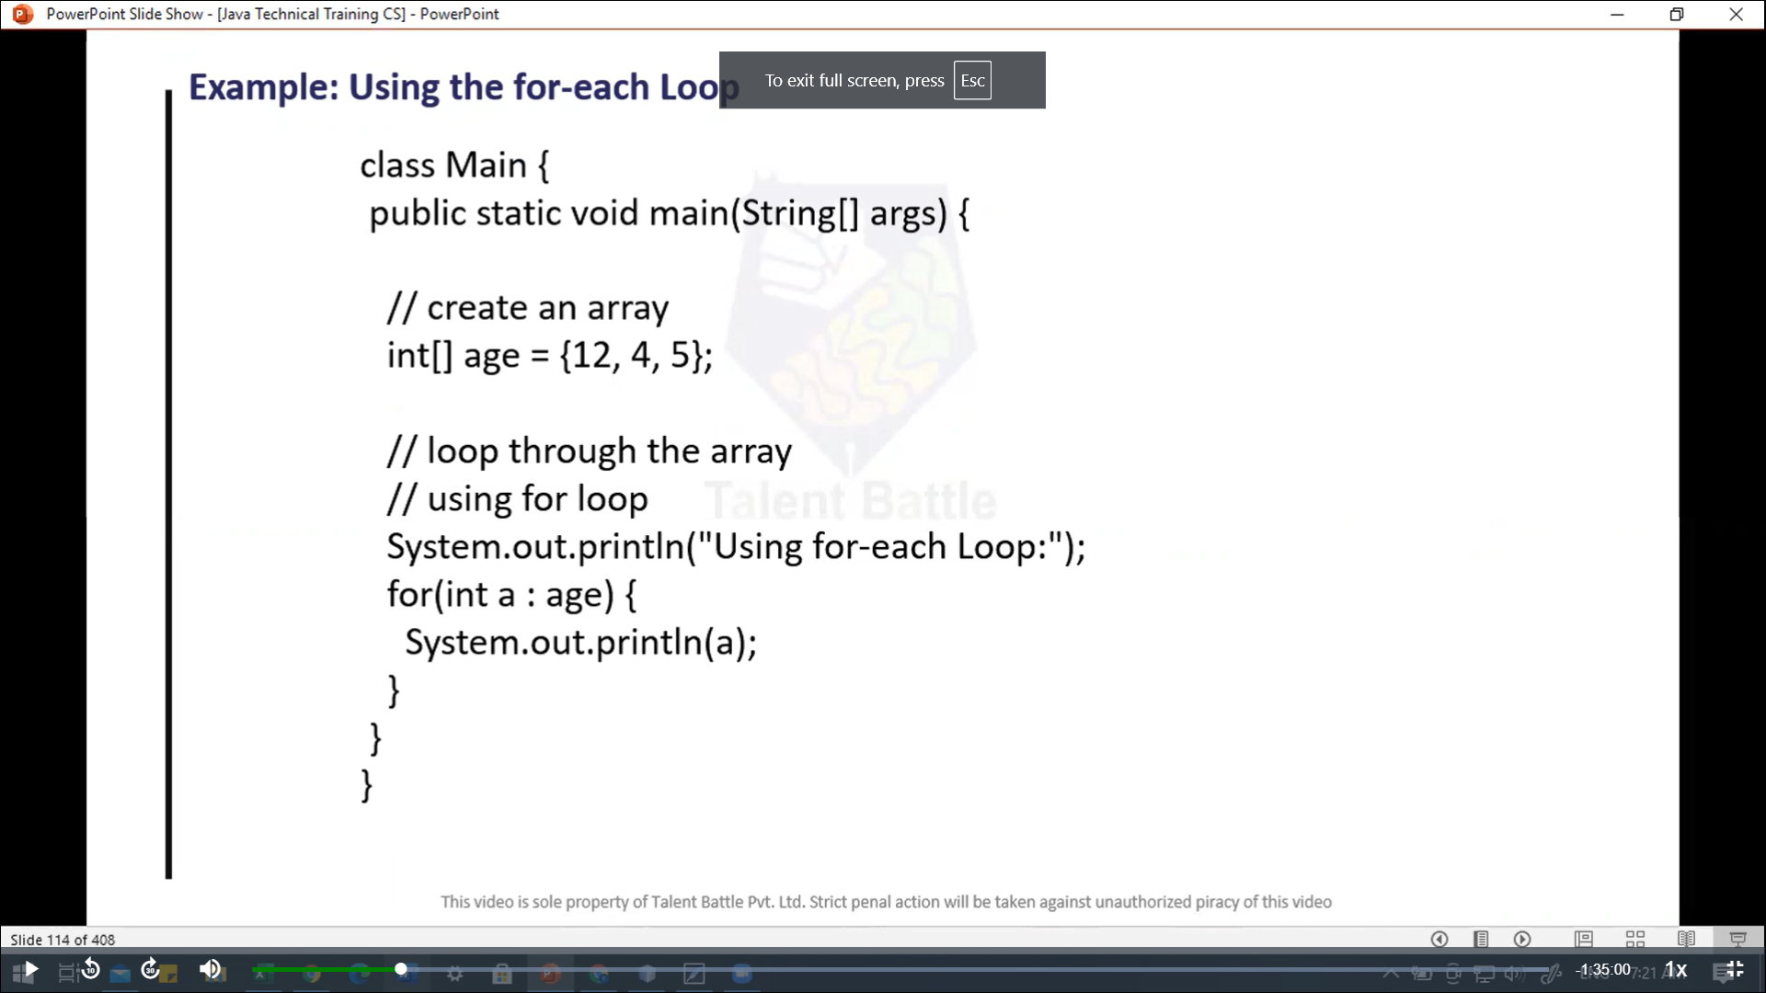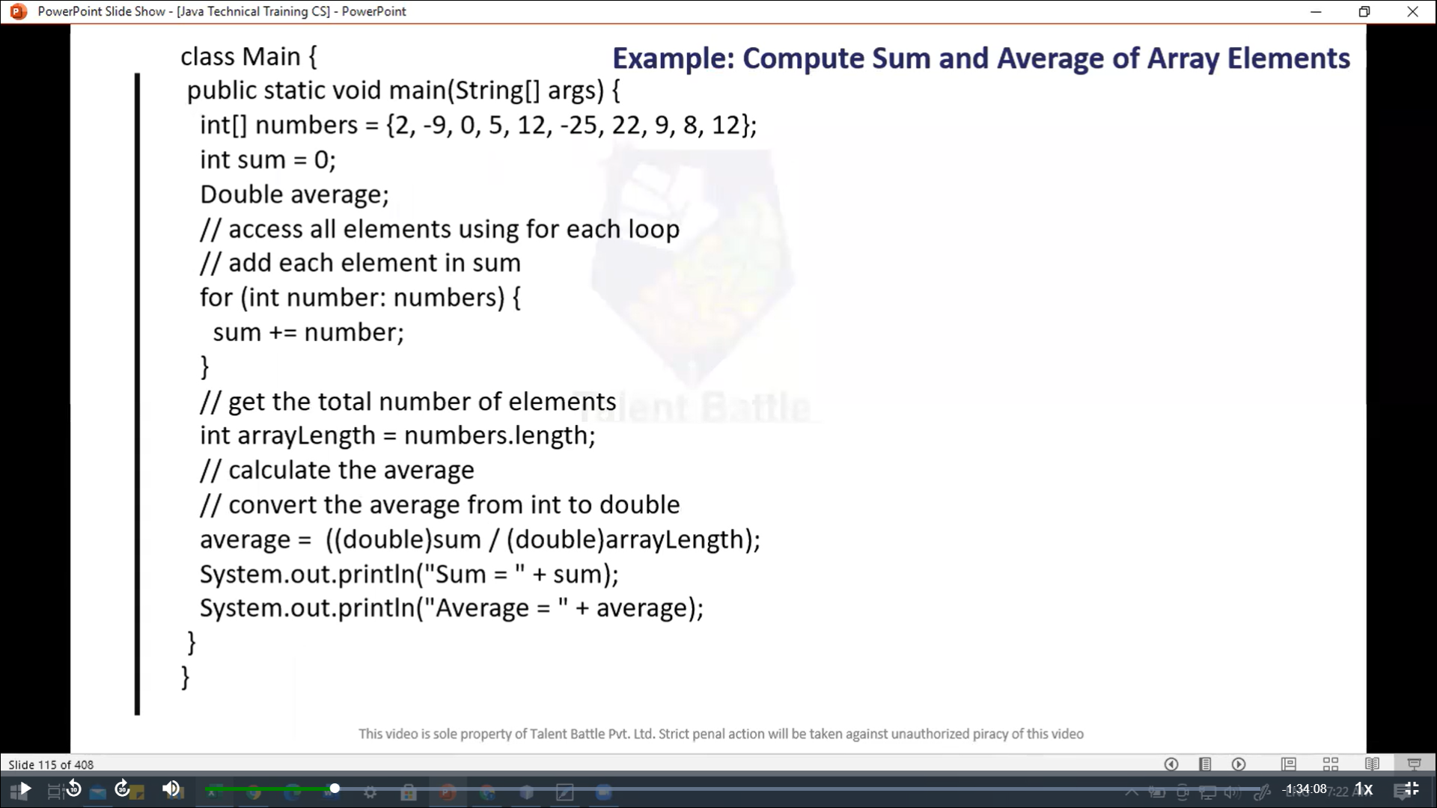

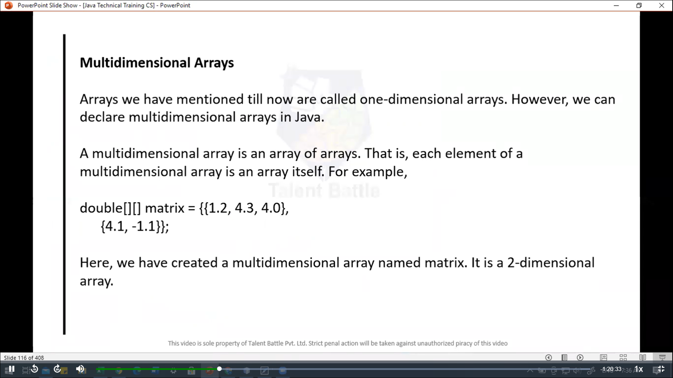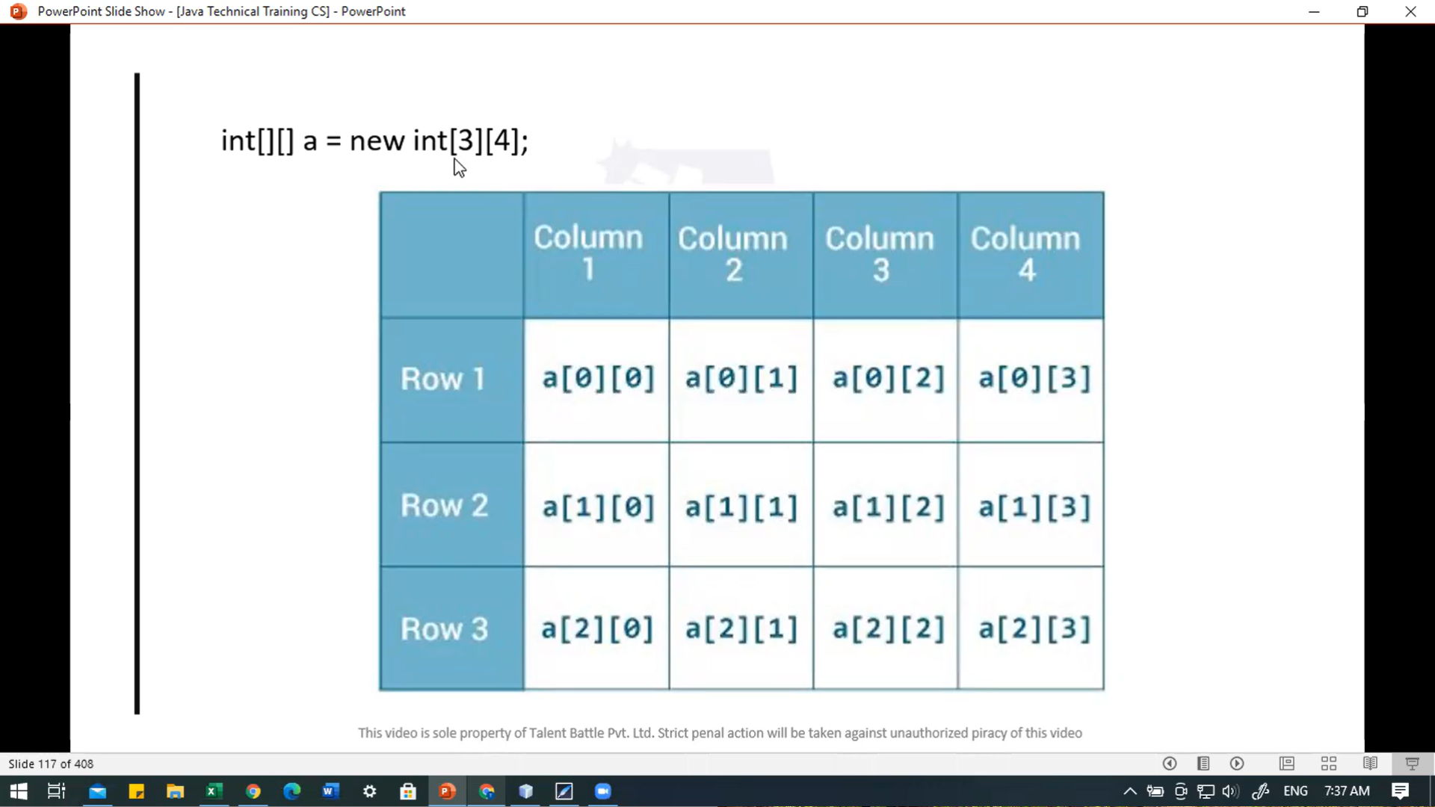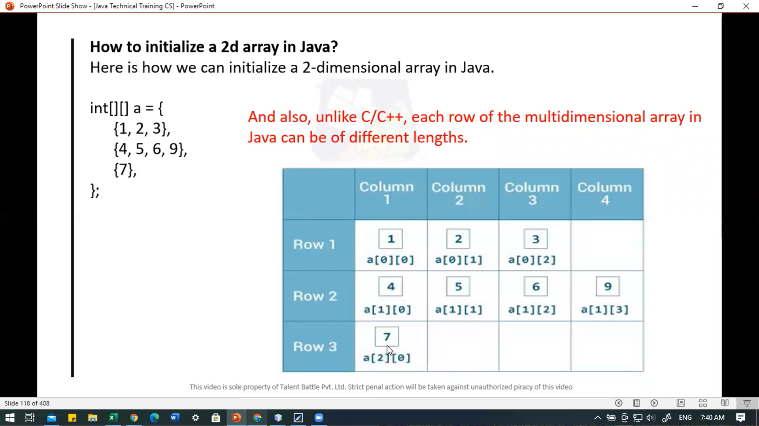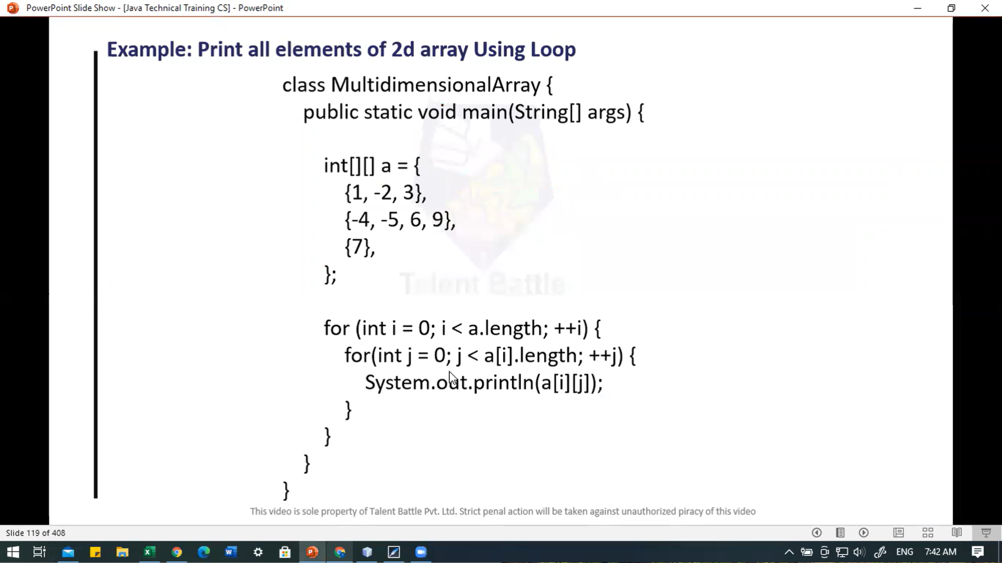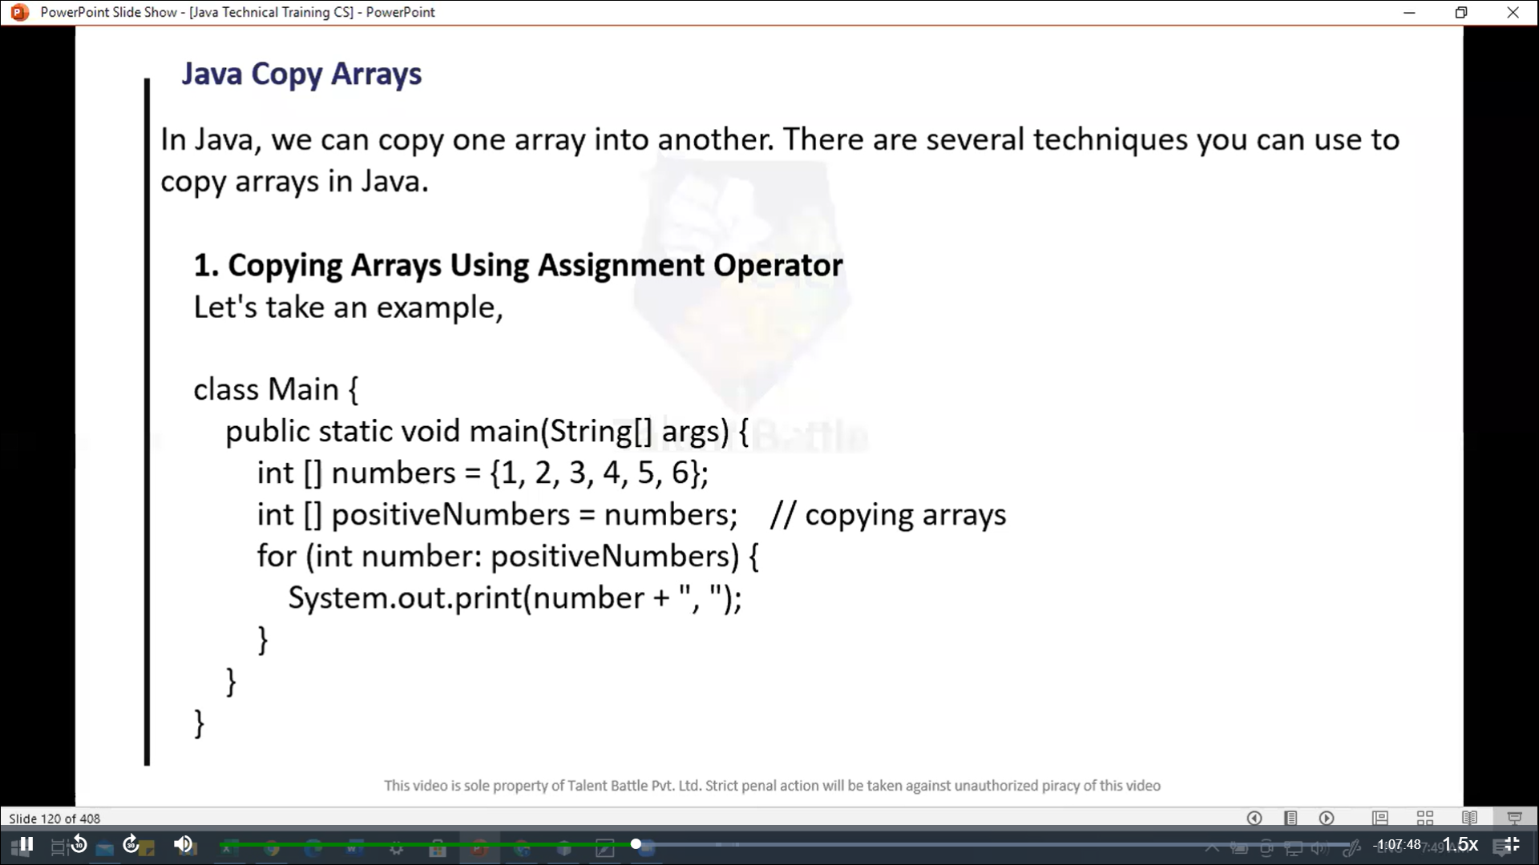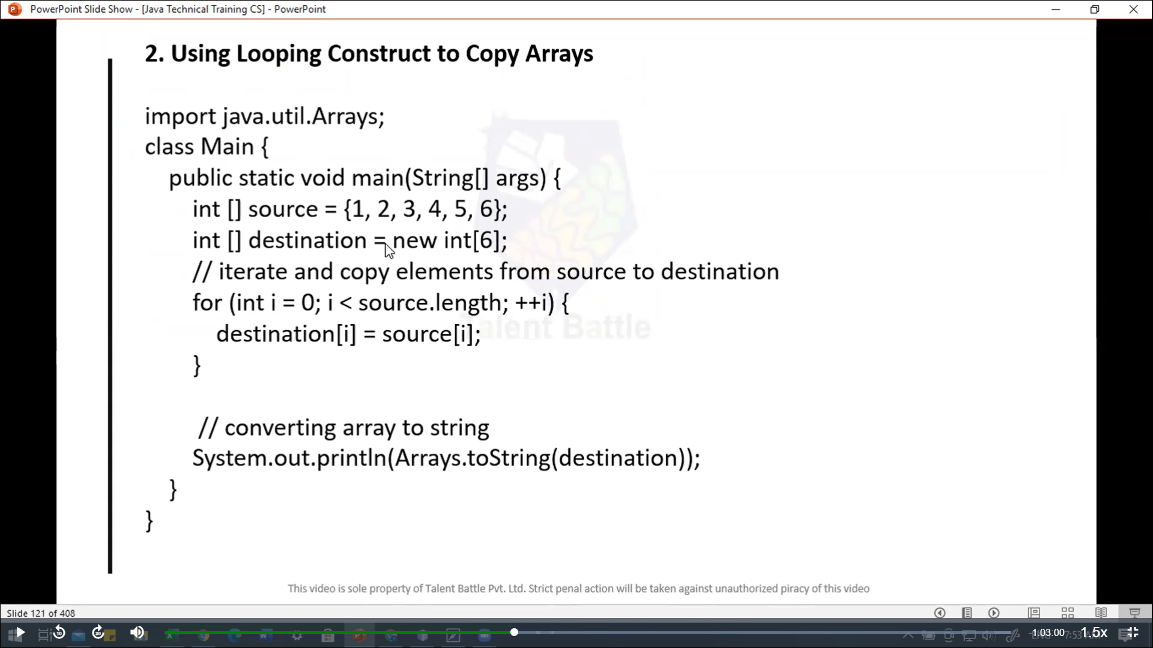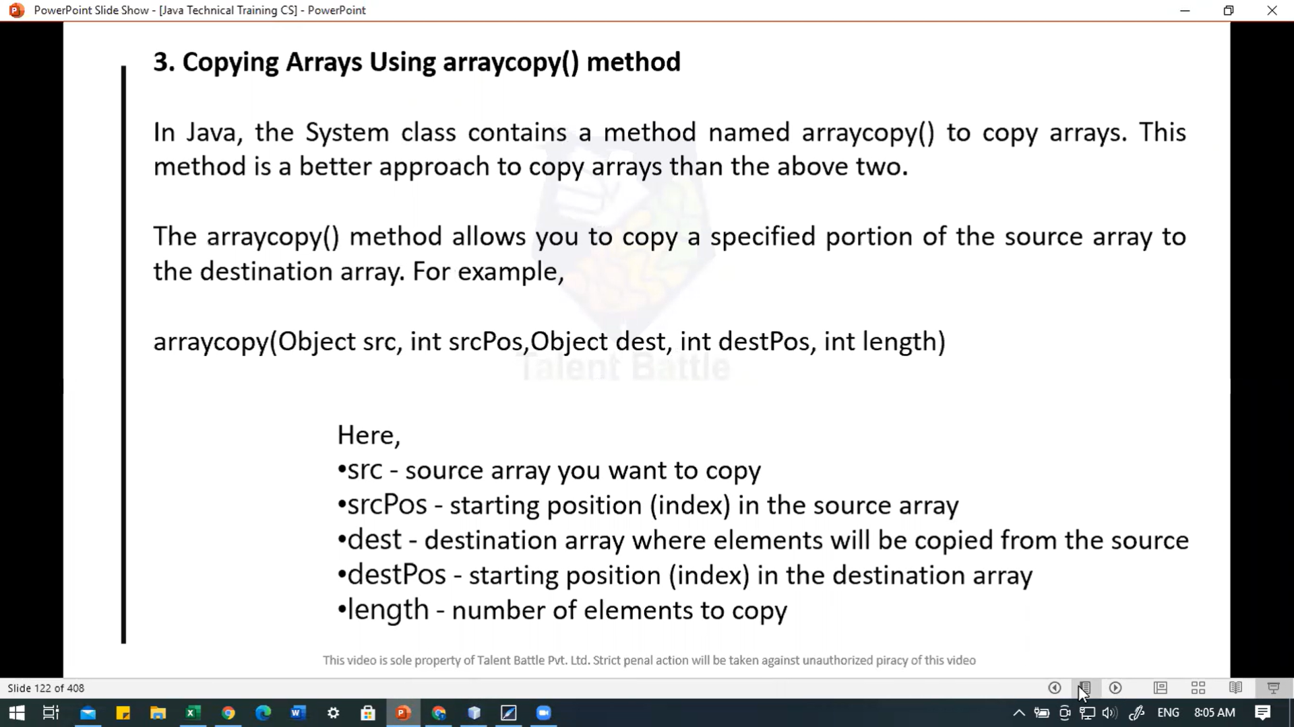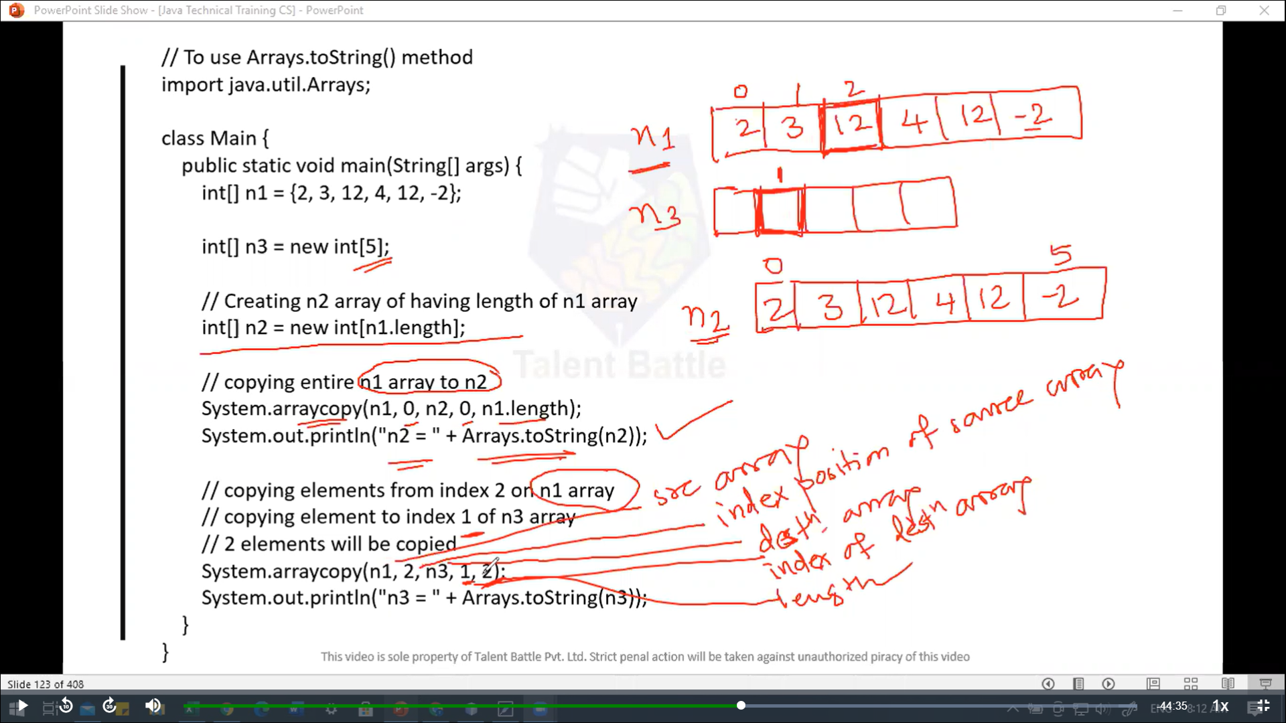

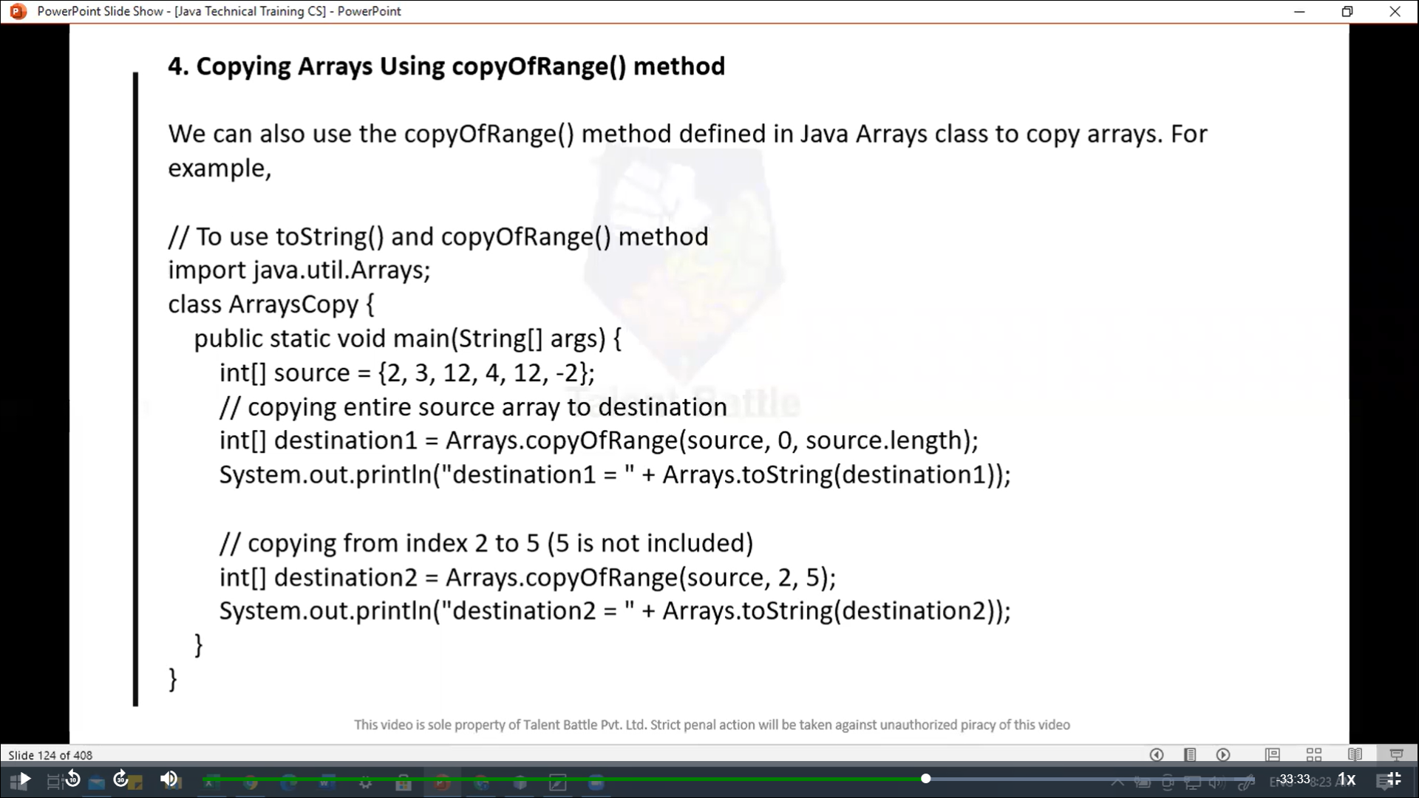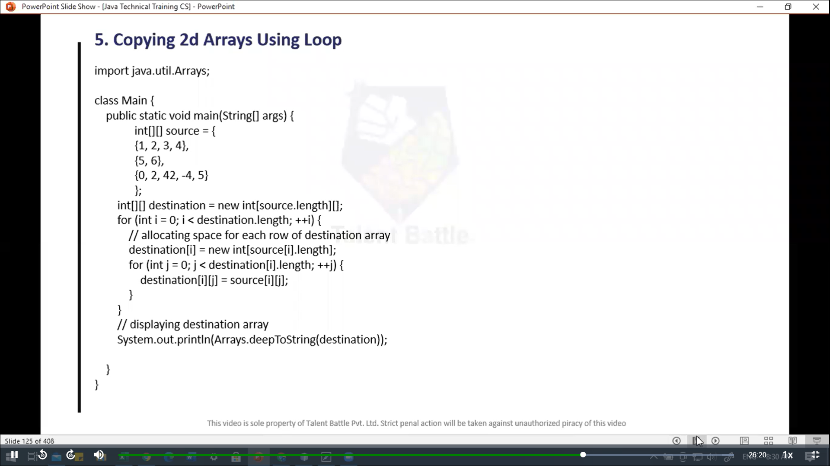

package Day4***;***

import java***.***util***.***Arrays***;***

import java***.***util***.***\****;***

public class Main {

  public static void *main*(String[] ***args***) {

    // access array elements

    /*

    // create an array

    int[] age = {12, 4, 5, 2, 5};

    // access each  array elements

    System.out.println("Accessing Elements of Array:");

    System.out.println("First Element: "+ age[0]);

    System.out.println("Second Element: "+ age[1]);

    System.out.println("Third Element: "+ age[2]);

    System.out.println("Fourth Element: "+ age[3]);

    System.out.println("Fifth Element: "+ age[4]);

    for(int i = 0; i < age.length; i++){

      System.out.println(age[i]);

    }

     */

    //---------------------------------------------------------------

    /*    // looping through Array elements

    // create an array

    int[] age = {12, 4, 5};

    // loop through the array

    // using for loop

    System.out.println("============ Using for loop=============\n");

    for(int i = 0; i < age.length; i++){

      System.out.println(age[i]);

    }

   */

   //---------------------------------------------------------

   /*

   // using the for-each loop

   // create an array

   int[] age = {12, 4, 5};

   // loop through  the array

   // using for loop

   System.out.println("============ Using for-each loop ==============\n ");

   for(int a : age){

    System.out.println(a);

   }

   */

   // -------------------------------------------------------------

   /*

   // Example: Computer Sum and Average of Array Elements

   int[] numbers = {2, -9, 0, 5, 12, -25, 22, 9, 8, 12};

   int sum = 0;

   Double average;

   // access all element using for each loop

   // add each element in sum

   for(int number: numbers){

    sum += number;

   }

   // get the total number of elements

   int arrayLength = numbers.length;

   // claculate the average

   // convert the average from int to double

   average = ((double)sum / (double)arrayLength);

   System.out.println("Sum = "+ sum);

   System.out.println("Average = " + average);

     */

  //-------------------------------------------------------

  /*

  // Example: print all element of 2d array using loop

  int[][] a = {

    {1, 2, 3},

    {4, 5, 6, 7},

    {8}

  };

  for(int i = 0; i < a.length; i++){

    for(int j = 0; j < a[i].length; j++){

      System.out.println(a[i][j]);

    }

    System.out.println();

  }

 */

 //--------------------------------------------------------

 /*

 // java copy Arrays

 int[] numbers = {1,2,3,4,5,6};

 int[] posityveNumbers = numbers; // copying arrays

 for(int number : posityveNumbers){

  System.out.print(number + ", ");

 }

System.out.println();

 int[] copy = Arrays.copyOf(numbers, numbers.length);

 System.out.println(Arrays.toString(copy)); // [1, 2, 3, 4,5,6]

 // copyOfRange() method is used to copy a range of elements from the original array to

 // the new array. The method takes two parameters: the original array and the range of

 // elements to be copied. The range is specified by the start and end indices.

 */

 //------------------------------------------------------------

 /*

 // Using looping construct to copy arrays

 int[] source = {1,2,3,4,5,6};

 int[] destination = new int[6];

 // iterate and  copy elements from source to destination

 for(int i = 0; i < source.length; i++){

  destination[i] = source[i];

 }

 // converting array to string

 System.out.println(Arrays.toString(destination)); // [1, 2, 3, 4, 5, 6]

 */

 //---------------------------------------------------------------------

 /*

 // To use Arrays.toString() method

 int[] n1 = {2, 3, 12, 4, 12, -2};

 int[] n3 = new int[5];

 // Creating n2 array of having length of n1 array

 int[] n2 = new int[n1.length];

 // copying entire n1 array to n2

 System.arraycopy(n1, 0, n2, 0, n1.length);

 // copying entire n1 array to n3

 System.out.println("n2 = " + Arrays.toString(n2));

 // copying elements from index 2 on n1 array

 // copying element to index 1 of n3 array

 // 2 elements wil be copied

 System.arraycopy(n1, 2, n3, 1, 2);

 // printing n3 array

 System.out.println("n3 = "  + Arrays.toString(n3));

 // ========== output ===============

//  n2 = [2, 3, 12, 4, 12, -2]

// n3 = [0, 12, 4, 0, 0]

*/

//==================================================================

/*

// Copying Arrays Using copyOfRange() method

// we can also use the copyOfRange() method defined in java Arrays class arrays.for example,

// To use toString() and copyOfRange() method

int[] source = {2, 3, 12, 4, 12, -2};

// copying entire source array to destination

int[] destination1 = Arrays.copyOfRange(source, 0, source.length);

System.out.println("Destination1 = " + Arrays.toString(destination1));

// copying from index 2 to 5 (5 is not included)

int[] destination2 = Arrays.copyOfRange(source, 2, 5);

System.out.println("Destination2 = " + Arrays.toString(destination2));

// ================== output: ==================

// Destination1 = [2, 3, 12, 4, 12, -2]

// Destination2 = [12, 4, 12]

*/

//=====================================================================

// Copying 2d Arrays using loop

int[][] source = {

  {1***,*** 2***,*** 3***,*** 4}***,***

  {5***,*** 6}***,***

  {0***,*** 2***,*** 42***,*** -4***,*** 5}

}***;***

int[][] destination = **new** int[source***.***length][]***;***

for(int i = 0***;*** i < destination***.***length***;*** i++){

  // allocating space for each row of destination array

  destination[i] = **new** int[source[i]***.***length]***;***

  for(int j = 0***;*** j < destination[i]***.***length***;*** j++){

    destination[i][j] = source[i][j]***;***

  }

}

// displaying destination array

System***.***out***.****println*("Destination = " + Arrays***.****deepToString*(destination))***;***

// ================== output ======================

// PS C:\Users\hp\Desktop\TCS IT\Java\Day4> java .\Main.java

// Destination = [[1, 2, 3, 4], [5, 6], [0, 2, 42, -4, 5]]

  }

}

**Java OOP**

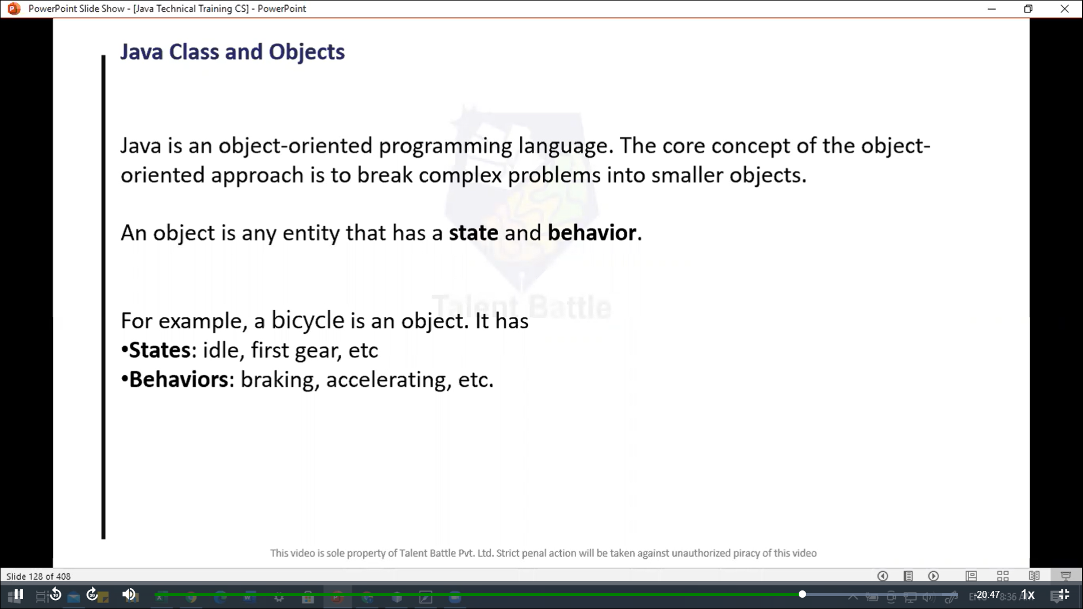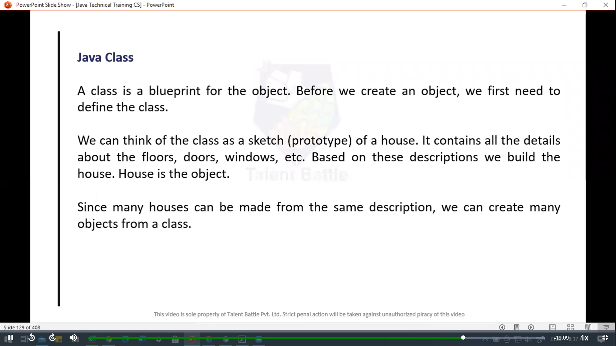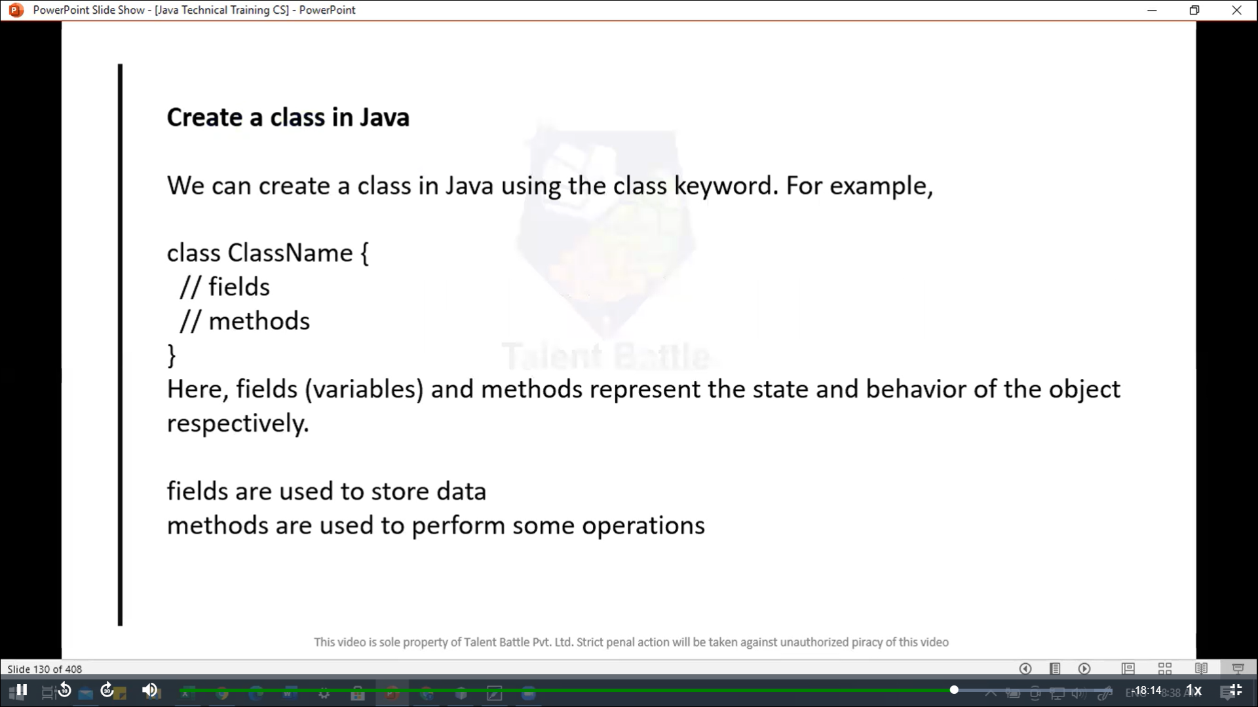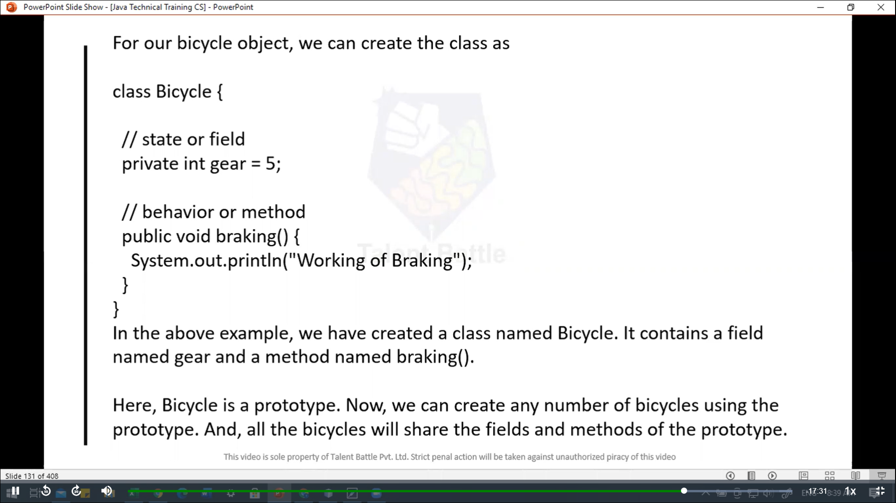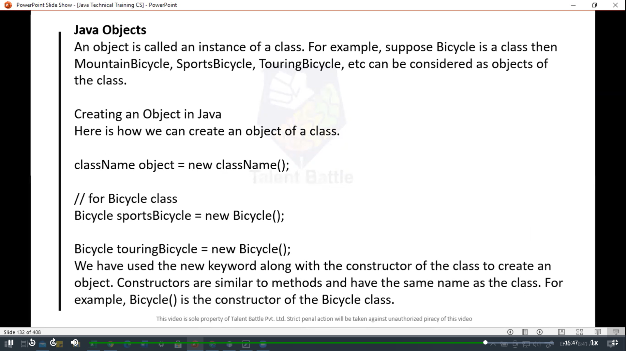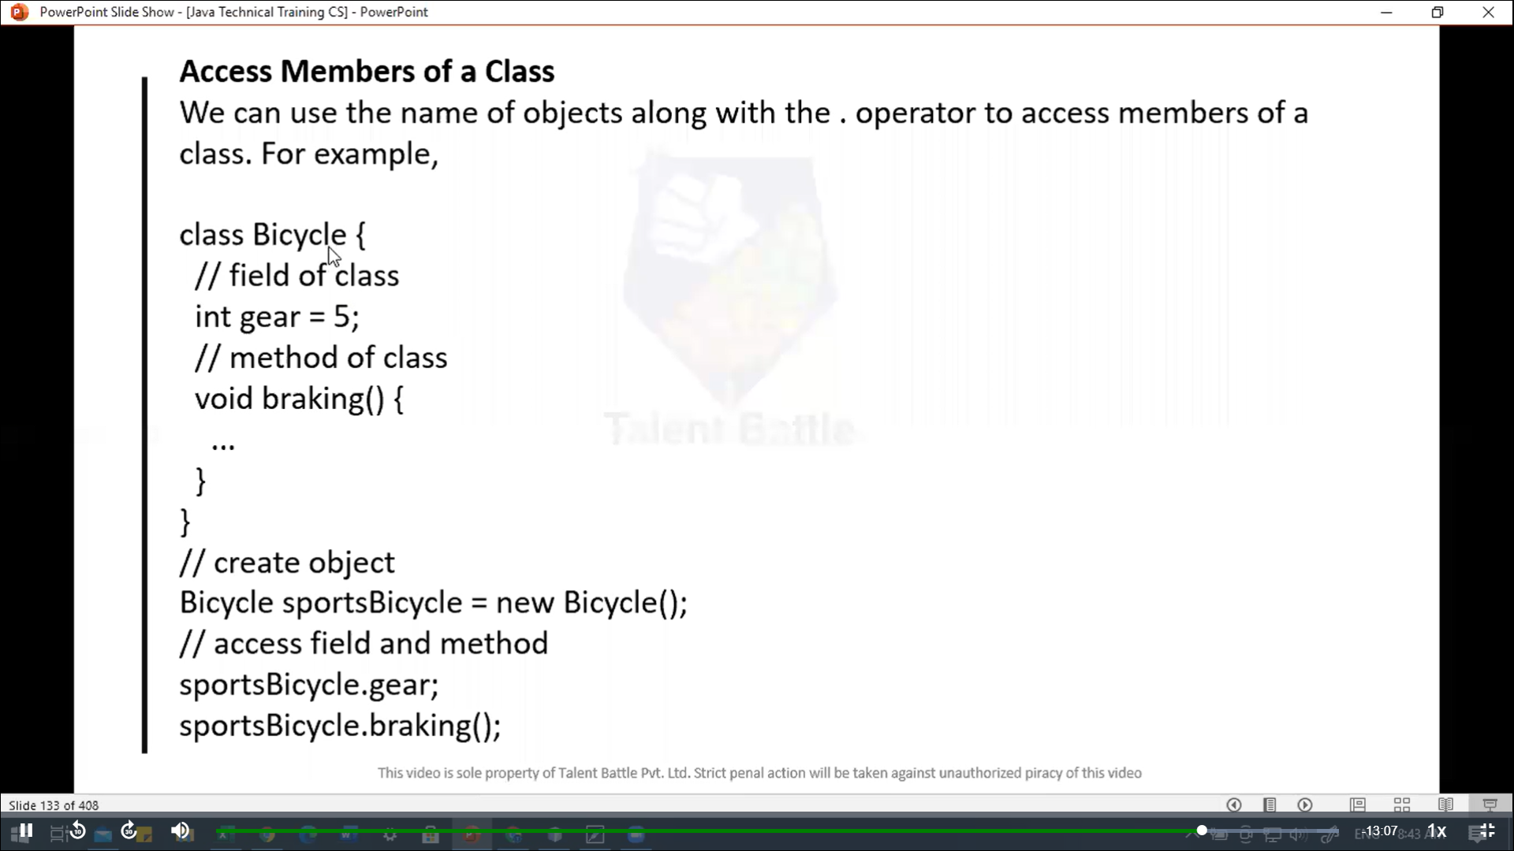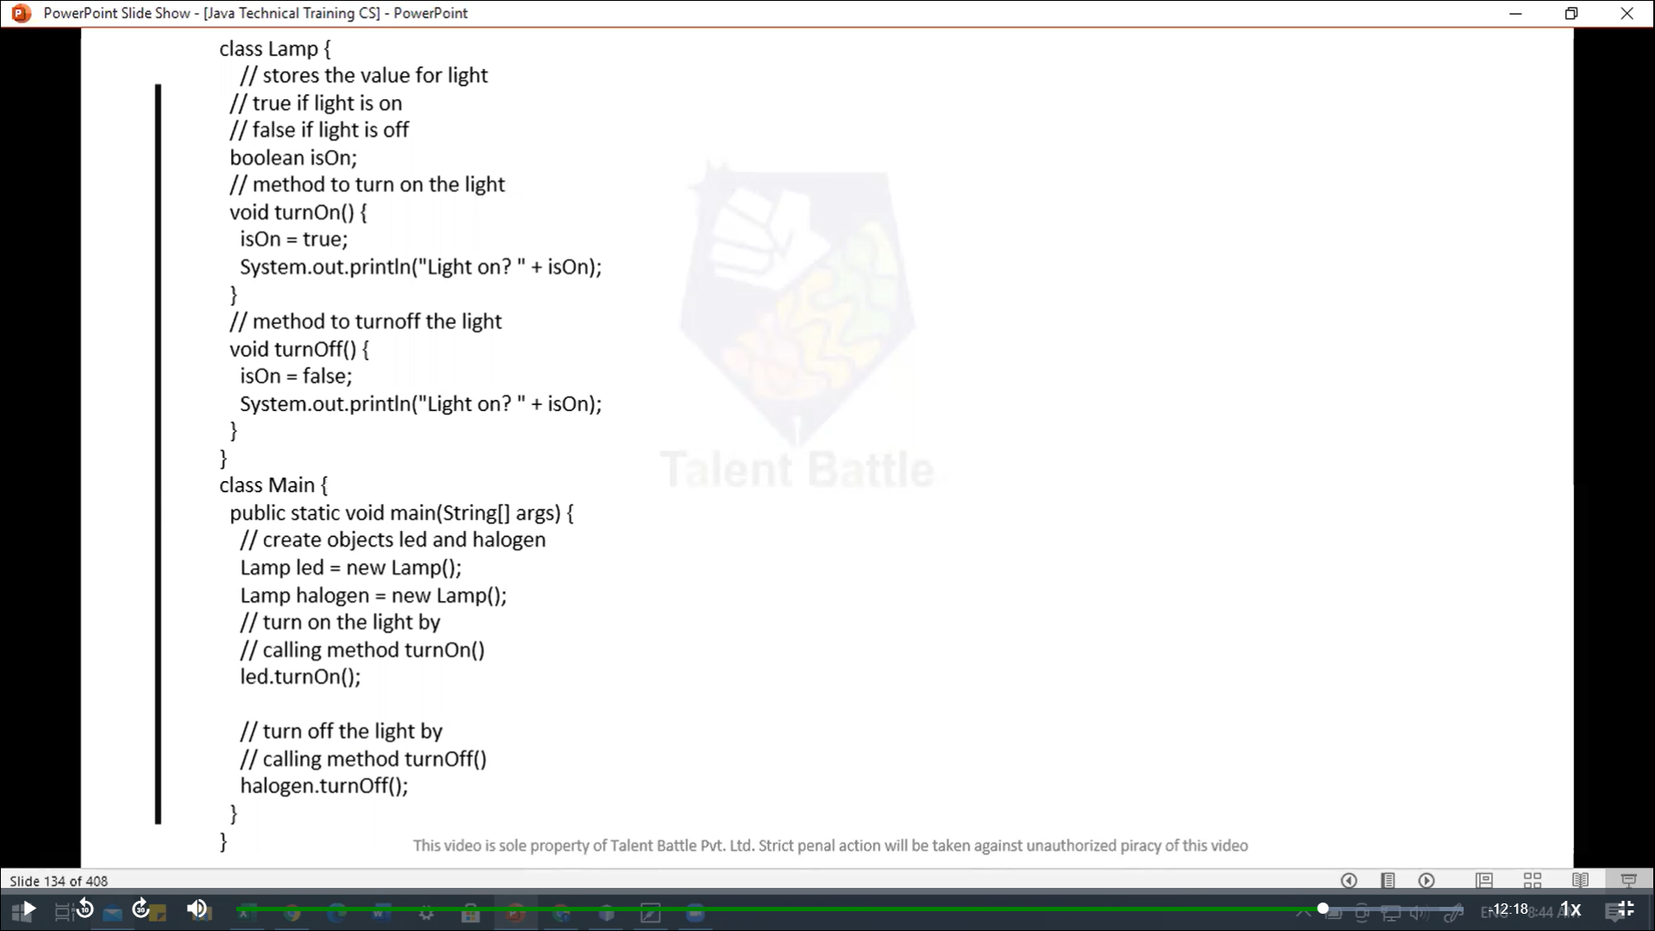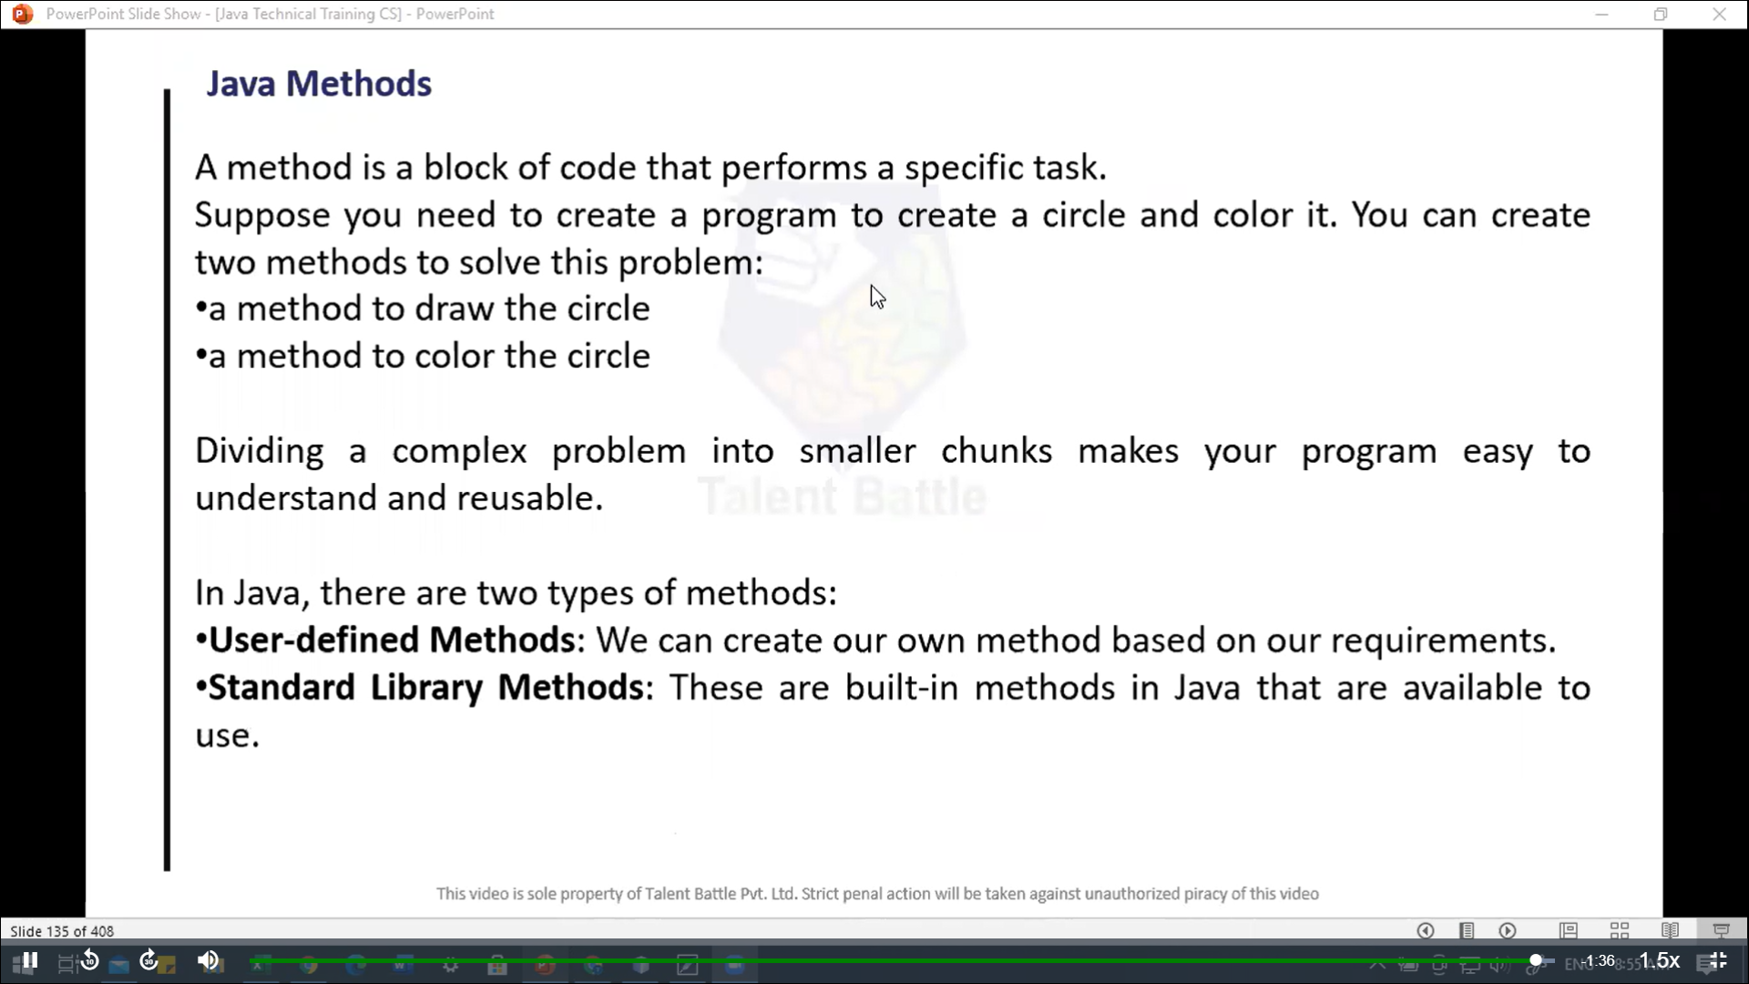

package Day4***;***

class Lamp {

  private boolean isOn***;***

  public *Lamp*() {

    this***.***isOn = **false*;***

  }

  public void *turnOn*(){

    isOn = **true*;***

    System***.***out***.****println*("Light is on")***;***

  }

  public void *turnOff*(){

    isOn = **false*;***

    System***.***out***.****println*("Light is off")***;***

  }

  public boolean *isLightOn*(){

    return isOn***;***

  }

}

public class Main1 {

  public static void *main*(String[] ***args***) {

    Lamp led = **new** *Lamp*()***;***

    Lamp halogen = **new** *Lamp*()***;***

    led***.****turnOn*()***;***

    System***.***out***.****println*("Is led light on? " + led***.****isLightOn*())***;***

    halogen***.****turnOff*()***;***

    System***.***out***.****println*("Is halogen light on? " + halogen***.****isLightOn*())***;***

    //====== output =============

//     PS C:\Users\hp\Desktop\TCS IT\Java> java Day4.Main1

// Light is on

// Is led light on? true

// Light is off

// Is halogen light on? false

// PS C:\Users\hp\Desktop\TCS IT\Java>

  }

}